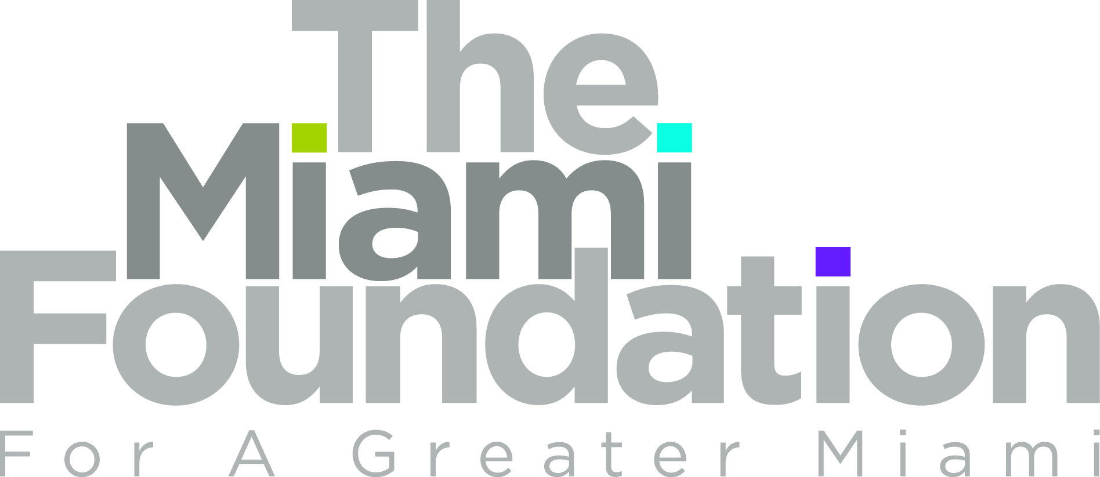

GLBT Community Projects Fund

2011 Proposal Guidelines
Proposal Deadline: Friday, August 5, 2011

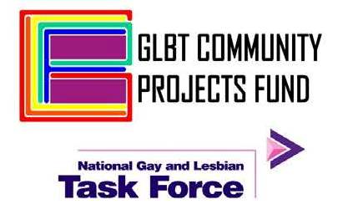
The GLBT Community Projects Fund is a unique partnership between The Miami Foundation and the National Gay and Lesbian Task Force, based in Washington, DC. In 2005, the Task Force assumed leadership for producing two signature events for Greater Miami’s GLBT community - the Winter Party Festival in the spring and the Miami Recognition Dinner in the fall. Thanks to the efforts of local GLBT leaders, a share of the proceeds from these events stays in the local community through a Fund established at the Foundation.

The Miami Foundation has a long history of supporting nonprofits working on gay and lesbian issues at the grassroots level. Through the GLBT Community Projects Fund at the Foundation, grants are awarded each year to deserving nonprofits in Greater Miami.

Community Purpose
The GLBT Community Projects Fund’s goal is to advance education and public awareness of GLBT issues and support the local GLBT community. The Fund’s committee considers proposals for general program support, specific projects and capacity building activities that further its priorities. The committee looks to award grants to projects that can achieve measurable results. From each proposal they are interested in knowing what problem is being addressed, how the proposed activities address that problem, what success would look like and how it will be measured.

Grant Size: Grants will range from $2,500 to $20,000 for one year.

Who can apply?
Applicants should be nonprofit organizations that have:
- Demonstrated involvement in addressing GLBT issues
- Projects and programs that benefit Miami-Dade County residents
- 501(c)(3) tax-exempt status or a fiscal agent partner that does. Case-by-case consideration will be given to grassroots groups or associations taking on important projects with a charitable purpose.
Nonprofits can submit one proposal where they would be the sole grant recipient, and also be part of one proposal that’s a collaborative effort, with partners jointly implementing activities and sharing grant dollars.

The Miami Foundation
The Miami Foundation connects philanthropy with community needs and opportunities to make Miami a greater place to live, work and play. Since 1967, the Foundation has been entrusted with $225M in custom, charitable Funds that allow us to support the arts, champion diversity, teach children to read and develop the next generation of leaders.
The GLBT Community Projects Fund at The Miami Foundation - Proposal Guidelines

Fund Priorities:
The Fund’s committee will consider requests that address current and emerging needs and has a particular interest in community building. Priority will be given to proposals deemed strongest in one of more of the areas below.
- Strengthen the programs and capacity of nonprofits whose main focus is serving the GLBT community as well as other groups that show commitment to addressing GLBT issues.
- Foster collaboration on programs and events among groups within the GLBT community and with other GLBT-friendly organizations.
- Address the health*, human service and social justice needs stated below. (*Health-related requests should focus on factors related to people’s sexual orientation that impact their health. Proposals focused primarily on HIV/AIDS generally won’t be supported.)
  - Homophobia and alienation of GLBT Haitian-Americans. This could include raising awareness, fostering dialogue and reaching these residents who suffer from being isolated and marginalized
  - Social services and health needs of transgender people
  - Services and support for homeless GLBT youth
  - Social justice efforts such as: advocacy to protect or advance civil rights and liberties or combat discrimination; non-partisan voter education on issues like legal rights of same-sex partners and GLBT parents
- Services and support that: assist GLBT youth and their families, seniors, African-American, Caribbean and Hispanic residents isolated due to race, ethnicity or economics; or address anti-GLBT violence or domestic violence in the GLBT community
- Expand offerings of cultural, educational and community-building projects presented along with the annual Winter Party Festival that reflect the lives and experiences of GLBT people. This might include exhibitions, performances, community forums, community dialogues, literary events, etc..
Grants may be used to support costs directly related to delivering the program or project, such as staff, consultants, supplies and materials, program-related travel, office support, media services as appropriate. Grants will not be made for memberships, events mainly intended for fundraising, memorials or to individuals.

Key Dates:
- Proposal Deadline: 4 pm on Friday, August 5, 2011
- Notification of Grant Awards – Week of September 19, 2011
- Grant Period: October 1, 2010 to September 30, 2012

Application & Review Process:
Submit one original and two copies of the proposal by the deadline. Proposals must be received in the Foundation’s office by the deadline via mail or delivery. Those sent by fax or email or received after the deadline will not be accepted.
Foundation staff will screen requests for eligibility and completeness. The Fund’s Committee will evaluate requests and may conduct meetings with applicants during the review process. The Foundation’s Board of Trustees has final approval of all grants awarded by the Foundation.
The GLBT Community Projects Fund at The Miami Foundation - Proposal Guidelines

The Proposal: Cover Sheet, Narrative, Budget and Other Required Attachments

Proposal Cover Sheet: Complete this form and attach it to the front of the proposal.

Narrative: In no more than three pages, provide the following information about your program or project. Please use a font size no smaller than 11 points and margins no less than ½ inch.
- Community Issue: What is the issue you seek to address and how does it affect the local community? What outcomes do you seek to achieve to impact that issue for the better?
- Proposed Program or Project: Describe your program and implementation plan including: your goals, the activities you will implement to meet those goals, when and where key activities will be conducted and an implementation timeline.
- Results: Explain how your proposed activities will bring about your desired outcomes and how you will measure those outcomes.
- Access to Target Populations: Describe the geographic area(s) and target population(s) the program will reach and serve. Include any distinctive characteristics. Explain the key approaches you will use to reach them, including relationships or collaborations with other groups.
- Your Organization:
  - Mission: What is your organization’s mission? How does the proposal reflect that mission?
  - Current Programs: What are the key programs or services you provide? What programs do you currently have that serve the GLBT community and how many people do they reach annually?
  - Capacity: Who are the key staff for this project, what are their responsibilities and qualifications? What other organizations, if any, are you collaborating with on this project and what are their roles? What is the agency’s experience and success record with this or similar programs?
- This Grant: How would this grant be particularly valuable to moving the program forward? What are your plans for sustaining the program and what main sources of financial support are you pursuing?

Required Attachments
- Performance & Results Form: Complete the form to reflect your results and performance goals.
- Proposal Budget: Use the Foundation’s form to clearly show: (a) the total cost of the proposed program or project, what line item expenses this grant would cover and a brief narrative explanation of those line items; (b) income sources, how much is secured, what is pending and when a decision is expected.
- Organization’s Operating Budget for the current fiscal year
- IRS 501(c)(3) Determination Letter to show you or your fiscal agent are a tax-exempt organization
- Current Board List
Other documents on the organization’s fiscal strength may be requested during the review process.

Evaluation Criteria
Only complete proposals will be considered. The most competitive proposals will be those that show clarity and strength in terms of addressing the Fund’s priorities, achieving measurable results, delivering quality activities that can lead to those results and effectively using the grant to achieve the project’s goals.

Address Proposals To:  Javier Alberto Soto, President & CEO  The Miami Foundation  200 South Biscayne Blvd, Suite 505  Miami, FL 33131 | For Questions & Information Contact:  Pamela Cirimele, Programs Assistant  The Miami Foundation  305-371-2711  pcirimele@miamifoundation.org

2011 GLBT Community Project Fund Proposal - Cover Sheet

Submit one original and two copies of the proposal by 4 pm on August 5, 2011. Proposals must be received in the Foundation’s office by the deadline via mail or delivery. Those sent by fax or email or received after the deadline will not be accepted.

Organization Name:
Federal Tax-ID Number:
Mailing Address:
Executive Director/CEO:
Phone Number: |  | Email:
Proposal Contact: |  |  |  | Title:
Phone Number: |  | Email:

If using a Fiscal Agent:
Fiscal Agent Name
Federal Tax-ID Number:
Mailing Address:
Contact Person: |  |  |  | Title:
Phone Number: |  | Email:

Amount of Request: | $ | Total Project Budget: |  | $
Agency’s Total Current Budget: | $ |  | Prior Year Total Budget: | $

Project Description: Provide a summary description of the proposed program or project. (60 words or less)

Signature of Executive Director/CEO or person authorized to approve grant submissions

Printed Name & Title Date

2011 GLBT Community Projects Fund Proposal
Results & Performance Form

Results: What are the top three outcomes you want to achieve that will show a measurable difference in how participants will be better off as a result of the program?
What is the desired outcome? | How will you measure results?  (What tools or methods)

Performance Measures: List the main activities you will conduct and the information related to each.
What is the activity? How does it lead to your outcomes? | How often will it occur?  (daily, weekly, monthly, one-time) | How many will you reach?

